SET 25: WEBSITE TRAFFIC ANALYSIS
AIM
To analyze website traffic using page views, click-through rates, user interactions, and graphical visualizations in R.
DATASET
Date | Page Views | Click-through Rate
2023-01-01 | 1500 | 2.3%
2023-01-02 | 1600 | 2.7%
2023-01-03 | 1400 | 2.0%
2023-01-04 | 1650 | 2.4%
2023-01-05 | 1800 | 2.6%
PROGRAM 1: LINE CHART OF PAGE VIEWS
Aim: To visualize the trend in website page views over time.
Procedure:
- Enter the date and page-view data in R.
- Convert dates into Date format.
- Create a line chart with points.
- Add the chart title and axis labels.
R CODE:
date <- as.Date(c("2023-01-01","2023-01-02",
"2023-01-03","2023-01-04","2023-01-05"))
views <- c(1500,1600,1400,1650,1800)
plot(date, views, type="b", col="blue", pch=19,
main="Website Page Views",
xlab="Date", ylab="Page Views")
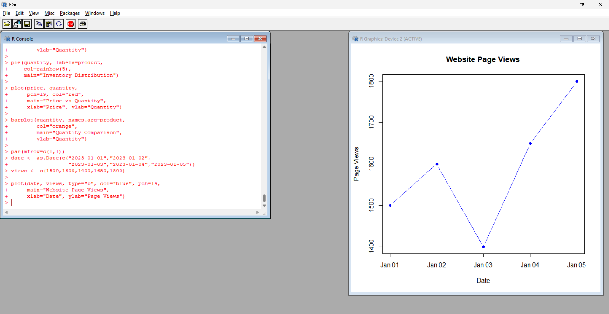
Output: A line chart showing daily page views.
Observation: Page views fluctuate over the five-day period. The highest value is 1800 on January 5, and the lowest value is 1400 on January 3.
PROGRAM 2: TOP DAYS WITH HIGHEST CLICK-THROUGH RATES
Aim: To identify the three days with the highest click-through rates.
Procedure:
- Enter dates and click-through rates.
- Sort the rates in descending order.
- Select the top three values.
- Display the values using a bar chart.
R CODE:
date <- c("Jan 1","Jan 2","Jan 3","Jan 4","Jan 5")
ctr <- c(2.3,2.7,2.0,2.4,2.6)
top <- order(ctr, decreasing=TRUE)[1:3]
barplot(ctr[top], names.arg=date[top],
col="orange", main="Top 3 CTR Days",
xlab="Date", ylab="CTR (%)")
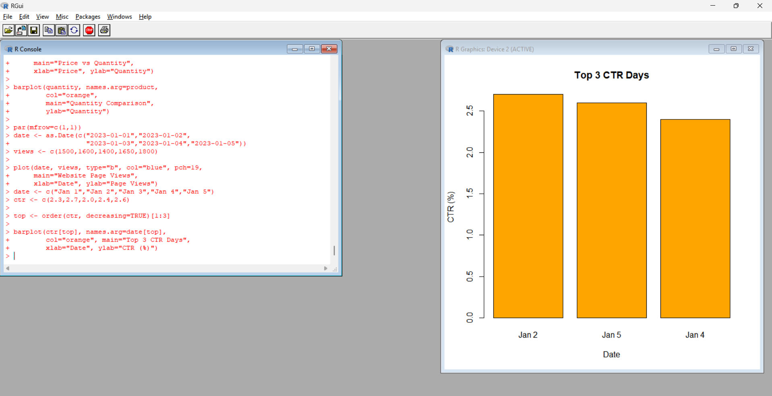
Output: A bar chart showing the top three click-through rates.
Observation: January 2 has the highest click-through rate of 2.7%, followed by January 5 at 2.6% and January 4 at 2.4%.
PROGRAM 3: STACKED AREA CHART OF USER INTERACTIONS
Aim: To visualize likes, shares, and comments using a stacked area chart.
Procedure:
- Create sample data for likes, shares, and comments.
- Calculate cumulative interaction values.
- Plot the stacked areas using different colors.
- Add a legend and axis labels.
R CODE:
day <- 1:5
likes <- c(100,120,90,140,160)
shares <- c(40,50,35,55,60)
comments <- c(25,30,20,35,40)
a <- likes
b <- likes + shares
c <- likes + shares + comments
plot(day, c, type="n", ylim=c(0,max(c)),
main="User Interactions",
xlab="Day", ylab="Interactions")
polygon(c(day,rev(day)), c(a,rev(rep(0,5))),
col="skyblue", border=NA)
polygon(c(day,rev(day)), c(b,rev(a)),
col="orange", border=NA)
polygon(c(day,rev(day)), c(c,rev(b)),
col="lightgreen", border=NA)
legend("topleft", c("Likes","Shares","Comments"),
fill=c("skyblue","orange","lightgreen"))
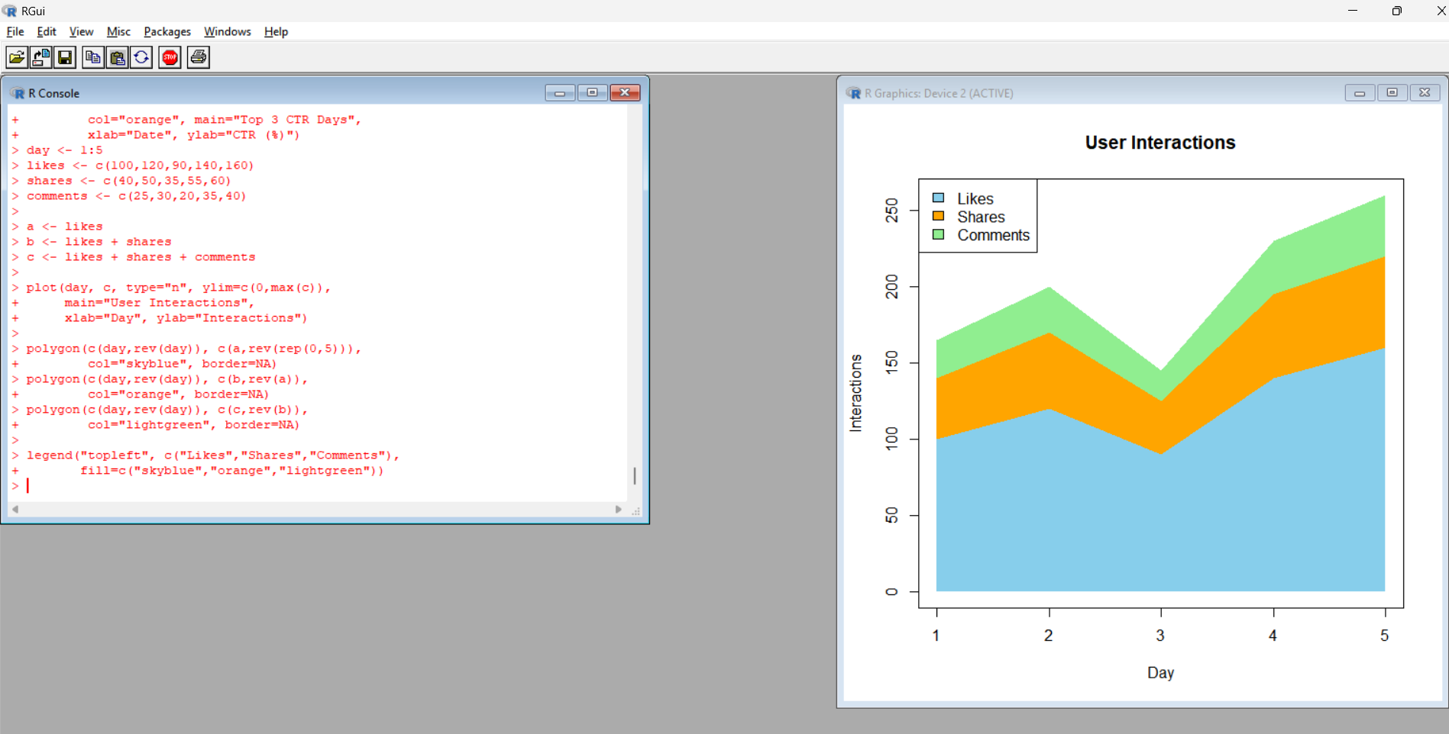
Output: A stacked area chart showing the distribution of user interactions.
Observation: The chart compares likes, shares, and comments over time. The interaction values are illustrative because the original dataset does not provide these counts.
PROGRAM 4: WEBSITE TRAFFIC DASHBOARD
Aim: To create a dashboard for exploring website traffic in RStudio.
Procedure:
- Create a bar chart for page views.
- Create a bar chart for click-through rates.
- Plot page views against click-through rates.
- Display summary statistics in a dashboard layout.
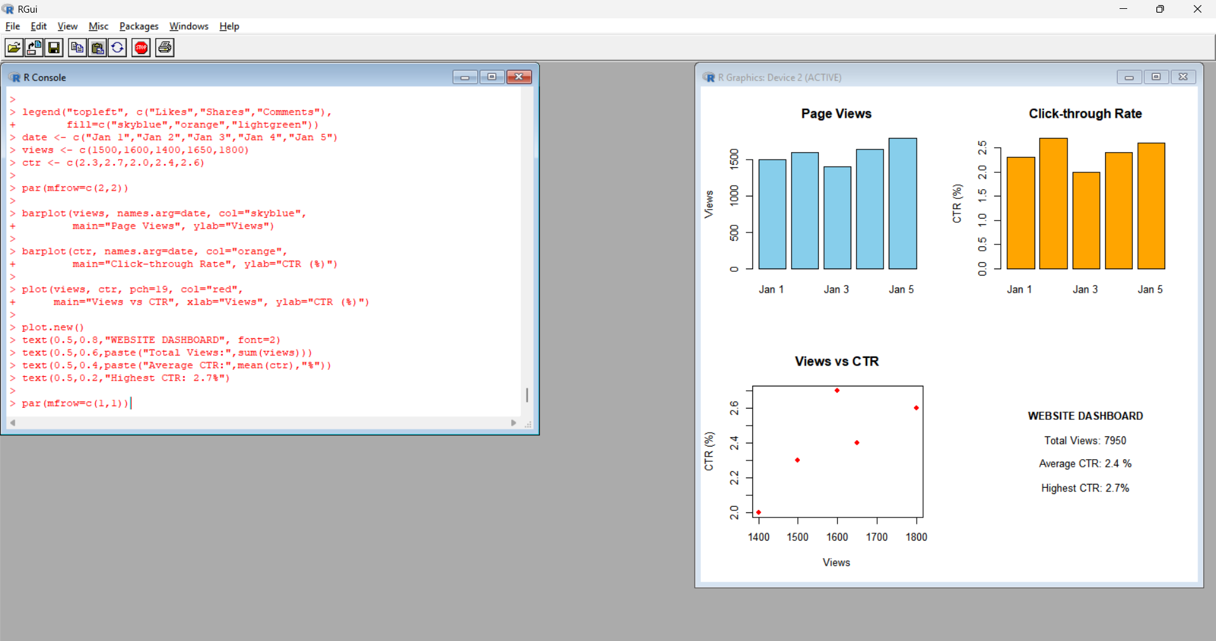
Output: A dashboard containing page views, click-through rates, their relationship, and summary information.
Observation: The total page views are 7950, and the average click-through rate is 2.4%. The dashboard provides an overview of website performance.
RESULT
Website traffic was analyzed using a line chart, bar chart, stacked area chart, and dashboard. January 5 recorded the highest page views, while January 2 recorded the highest click-through rate.

